**A Technological Solution to Prevent Suicidal Tendency**

**Among University Students**

**Md. Abu Towsif Farjana Yesmin Opi Abir Bokhtiar Shohanur Rahman Shohan**  
CSE, AIUB CSE, AIUB CSE, AIUB CSE, AIUB  
Dhaka, Bangladesh Dhaka, Bangladesh Dhaka, Bangladesh Dhaka, Bangladesh

22-47019-1@student.aiub.edu 22-47018-1@student.aiub.edu 22-47038-1@student.aiub.edu 22-46013-1@student.aiub.edu

[1] ***Abstract*—** **Suicidal thoughts and attempts are a growing concern among university students. This paper addresses the pressing issue of suicidal tendencies among university students and proposes a technological solution to prevent such occurrences. This study investigates the development of a comprehensive website platform tailored to provide mental health support specifically for university students. The implementation of such a technological solution requires careful consideration of privacy, ethics, and accessibility concerns. Therefore, this paper discusses the ethical implications of using technology in mental health support systems and proposes strategies to ensure user confidentiality and data security. Furthermore, the effectiveness of the proposed solution will be evaluated through pilot studies and user feedback. By using the power of technology, this initiative aims to create a supportive environment for university students, ultimately reducing the prevalence of suicidal tendencies and promoting overall well-being.**

***Index Terms*— Suicidal tendencies, University students, Mental health support, Technological solution, Website development**

1. INTRODUCTION
2. ***Background Information***

T

he issue of mental health among university students has garnered increasing attention in recent years. With a rapidly growing youth population and rising academic pressures, universities across the country are witnessing a concerning trend of mental health challenges, including suicidal tendencies among students. The competitive nature of the education system, coupled with high expectations from families and society, places immense pressure on university students to excel academically. Additionally, factors such as financial constraints, social isolation, and cultural stigmatization of mental health issues further exacerbate the vulnerability of students to mental health problems. A study reveals that at least 101 university students committed suicide in 2021, with 64.36% being male students.[1]

1. ***Overview***

This research aims to address the pressing issue of suicidal tendencies among university students in Bangladesh by proposing a technological solution tailored to the local context. Drawing upon the unique socio-cultural factors and challenges faced by students in Bangladesh, the proposed solution seeks to provide accessible and personalized mental health support through a comprehensive website platform The report focuses on the importance of introducing new technology to address the mental health challenges faced by university students and to provide them with effective support systems.

# METHODS

1. ***Description of the solution***

A valuable tool for promoting mental well-being among university students in Bangladesh can be served by a website platform. This can be achieved by offering a combination of functionalities containing self-assessment tools for depression and anxiety, educational resources on mental health awareness and suicide prevention, crisis support options with hotlines, anonymous chat functionality with trained professionals, and peer-to-peer connections with a sense of community and belonging for students facing similar challenges. By empowering students to take charge of their mental health and prevent potential tragedies, the website can make a significant impact.

1. ***Method Used***

A questionnaire-based survey was conducted among 30 university students in Bangladesh to understand their mental health challenges, preferred coping mechanisms, and technology usage patterns. Google Form was used to prepare and distribute the questions. Responses were collected from April 16 to April 21 of the year 2024. Existing research papers on student mental health, suicide prevention strategies, and the effectiveness of website interventions were analyzed.

1. ***Rationale of selection participants***

Students were chosen for the survey because mental health problems like feeling sad or thinking about harming themselves are often experienced by them. They often encounter a lot of challenges, including school stress and other factors. Their experiences are being understood to help them better.

# RESULTS AND DISCUSSION

1. ***Results***

It could be observed from figure 1 that more than half of the students reported experiencing feelings of isolation or loneliness during their time at university.

Forms response chart. Question title: Have you ever felt isolated or lonely during your time at university?
. Number of responses: 30 responses.

Fig 1. Number of students felt isolated or lonely during university time

Figure 2 illustrates two-thirds of students experienced of intense sadness or hopelessness in the past year.

Forms response chart. Question title: In the past year, have you experienced feelings of intense sadness or hopelessness?
. Number of responses: 30 responses.

Fig 2. Number students felt of intense sadness or hopelessness in the past year

Figure 3 revealed that with more than half of students thought for suicide. This highlights the urgency of addressing mental health concerns among university students.

Fig 3. Number of Students thought for suicide.

It could be noticed from the pie chart of figure 4 that one-thirds of students did not feel comfortable talking to someone about their mental health concerns.

Forms response chart. Question title: Do you feel comfortable talking to someone about your mental health concerns?
. Number of responses: 30 responses.

Fig 4. Talking to someone about mental health concerns

Figure 5 shows that two-thirds of participant thought having a supportive community could positively impact mental health among university students.

Forms response chart. Question title: Do you think having a supportive community could positively impact mental health among university students?
. Number of responses: 30 responses.

Fig 5. Impact of having a supportive community.

From the perspective of the pie chart of figure 6, more than half of the students agreed that a community base website can provide mental health support.

Forms response chart. Question title: Would you be interested in a community base website designed to provide mental health support to university students?
. Number of responses: 30 responses.

Fig 6. A community base website designed to provide mental health support.

1. ***Discussion***

From the data in the results section, it can be said that the solution to the problem of suicidal tendencies among university students can be minimize if a community base website can provide mental health support. One of the major findings is that 30 percent frequently and 46.7 percent of students occasionally feel isolated during university times. On the other hand, 23.3 percent of students had thought about suicide. Almost 77 percent of the students thought having a supportive community could positively impact mental health among university students.

As most of the respondents agreed on implementation of a community base website, where students can anonymously share their thoughts, feelings and can took mental support by each other or resources.

# conclusion

In conclusion, our research highlights the urgent need for effective mental health support systems for university students in Bangladesh. The findings indicate that a significant proportion of students experience feelings of isolation, sadness, and thoughts of suicide, underscoring the severity of the issue. However, there is hope in the form of technological interventions, such as community-based websites, which have been shown to positively impact mental health outcomes among students. By leveraging such solutions, we can create a supportive environment where students feel comfortable seeking help and connecting with peers, ultimately reducing the prevalence of suicidal tendencies and promoting overall well-being.

1. ***Limitation***

Despite the valuable insights gained from our research, there are certain limitations to consider. Firstly, the sample size of our survey was relatively small, which may limit the generalizability of the findings. Additionally, the survey relied on self-reported data, which could be subject to biases or inaccuracies. Moreover, the study focused solely on university students in Bangladesh, and the findings may not be applicable to other demographic groups or cultural contexts. Future research should aim to address these limitations by conducting larger-scale studies with diverse populations and employing more rigorous methodologies.

Forms response chart. Question title: Have you ever felt isolated or lonely during your time at university?
. Number of responses: 30 responses.

1. ***Suggestions***

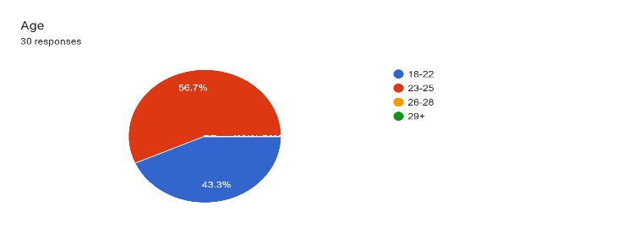Based on our findings, we suggest several recommendations for addressing the mental health challenges faced by university students in Bangladesh. Firstly, there is a need for increased awareness and destigmatization of mental health issues within educational institutions. Universities should prioritize the implementation of mental health programs and services, including the development of technology-driven solutions like community-based websites. Additionally, collaboration between universities, government agencies, and mental health organizations is essential for ensuring comprehensive support for students. Finally, ongoing evaluation and refinement of these interventions are crucial to ensure their effectiveness and relevance in addressing the evolving needs of students.

References

[1] Bala, S., Hasan, A. T., Jewel, Z. A., & Sarker, P. (2020). "Suicidal Ideation Percentage among University Students in Bangladesh." Huazhong Agricultural University and Sejong University. [onlilne]https://www.researchgate.net/publication/343682285_Suicidal_Ideation_Percentage_among_University_Students_in_Bangladesh#:~:text=12.4%25%20of%20Male%20students%20had,17.4%25%2C%2015.5%25%20respectively.

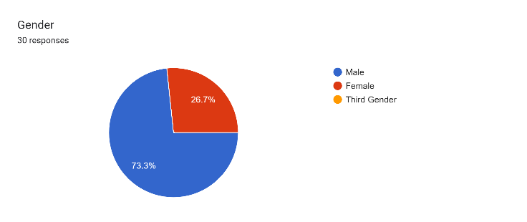

[2] Islam, M. S., Kabir, M. S., & Sultana, Y. (2016). Mental health problems among university students in Bangladesh: A cross-sectional study. International Journal of Mental Health and Addiction, 14(3), 437-447. [DOI: 10.1007/s11469-015-9521-0]

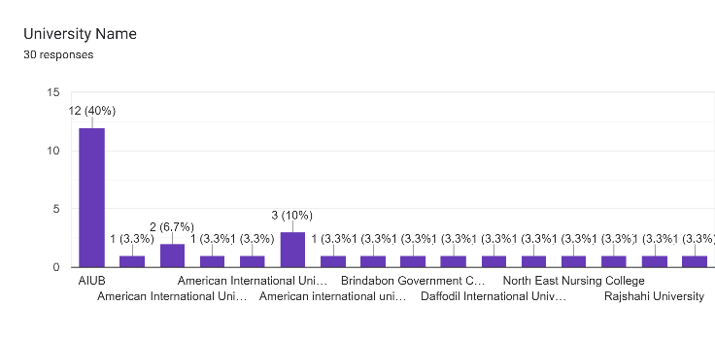[3] Cao, V. H., & Bui, T. T. H. (2018). Culturally appropriate interventions for mental health promotion in developing countries. International Review of Psychiatry, 30(2), 119-129. [DOI: 10.1080/09540261.2017.1404222]

[4] S. Akter Urme, M. S. Islam, H. Begum, and N. M. R. A. Chowdhury, "Risk factors of suicide among public university students of Bangladesh: A qualitative exploration," *Journal Title*, vol. (Issue), pp. pages, Year.

acknowledgment

We would like to sincerely thank our course teacher for their invaluable guidance, encouragement, and support throughout the duration of this project. Their expertise and mentorship have been instrumental in shaping our research journey and refining

our ideas. We are truly grateful for their dedication to our academic and personal growth. We are also grateful to everyone who has taken part in the survey. We appreciate the effort of each and every individual who contributed to the completion of the survey.

appendix

Forms response chart. Question title: Do you feel comfortable talking to someone about your mental health concerns?
. Number of responses: 30 responses.

Forms response chart. Question title: How often do you engage in self-care activities to manage your mental health?
. Number of responses: 30 responses.

Forms response chart. Question title: Do you think the university curriculum adequately addresses mental health awareness?
. Number of responses: 30 responses.

Forms response chart. Question title: Do you think having a supportive community could positively impact mental health among university students?
. Number of responses: 30 responses.

Forms response chart. Question title: Do you believe that technology-based platforms can effectively support mental health initiatives for university students?
. Number of responses: 30 responses.

Forms response chart. Question title: Would you be interested in a community base website designed to provide mental health support to university students?
. Number of responses: 30 responses.

Forms response chart. Question title: What features would you find most helpful on a mental health support website?
. Number of responses: 30 responses.

Forms response chart. Question title: How comfortable would you be sharing your experiences anonymously on a forum?
. Number of responses: 30 responses.

Forms response chart. Question title: In the past year, have you experienced feelings of intense sadness or hopelessness?
. Number of responses: 30 responses.Forms response chart. Question title: Would you prefer to connect with other students who are facing similar challenges through the website?
. Number of responses: 30 responses.

1. .